Towards In-Process Prediction of Voids in Laser Powder Bed Fusion
Sean O’Loughlin¹, Benjamin Dutton¹, Gent Semaj¹, Eric Snell¹, Jacob Rindler¹ and Michael A. Groeber^{2,*}
¹ The Ohio State University, Center for Design and Manufacturing Excellence, Columbus, OH 43210
² The Ohio State University, Department of Integrated Systems Engineering, Columbus, OH 43210

* Corresponding author
E-mail: groeber.9@osu.edu
Abstract
In this work, we investigate a framework for collecting, processing, and registering in-process monitoring data from an additive manufacturing build with post-build inspection data obtained from CT scans of the produced samples. In addition to processing and combining the data, we look at a statistical analysis of the combined data streams using machine learning methods to obtain a quantitative prediction of local void probability in the CT data from local feature metrics extracted from the in-process monitoring data. Results show promise when the in-process monitoring data is processed to extract designed features/metrics, rather than using the only raw signals.
Keywords: additive manufacturing, data registration, in-situ process monitoring, machine learning

1. Introduction
Additive Manufacturing (AM) is a processing technique that enables users to manufacture complex geometries from digital part files [1]. The opportunity to eliminate part-specific tooling and consolidate a multi-part system into a single complex part makes AM attractive for several industries [2]. Laser-Powder Bed Fusion (L-PBF) is a form of AM that is the layer-by-layer fusing of metal powders into a desired geometry by exposure to a laser [3]. L-PBF is of particular interest to the aerospace and biomedical industries having been demonstrated on commonly utilized nickel, titanium, and aluminum alloys [4].
However, there are barriers in quality and reproducibility that must be overcome to increase widespread use of L-PBF in critical parts. Multiple common defect classes arise during L-PBF builds. Incomplete fusing between tracks or layers caused by process instability or improper process parameters [5] causes lack of fusion (LoF) porosity. LoF flaws severely affect the fatigue and fracture resistance of parts by creating crack initiation and growth sites [6,7]. Keyhole porosity is another defect common to L-PBF caused by excessive penetration of the laser, due to either too high laser power or too slow scan speeds [8,9]. Porosity may also form due to gasses trapped within the melt [10,11]. Finally, cracking can occur due to thermal stresses developed of the nonuniform and extreme heating and cooling rates during the printing process. Beyond defects, the microstructure of L-PBF parts is also susceptible to anisotropy due to the epitaxial growth of grains [12]. This inherent texture leads to anisotropic mechanical properties, which could be detrimental in a loaded part.
Many of these defects occur within or between individual melt tracks, making in-process monitoring of the melt pool integral to the understanding of where they form during the process [3]. In 2013 the US National Institute of Standards and Technology identified in-situ data acquisition as a priority area of research and development and a crucial barrier to AM implementation [13]. A majority of the early research of in-situ inspection of L-PBF uses an in-line camera set-up. In Berumen et al.’s work, electromagnetic radiation emitted by the melt pool was transmitted and then a camera was used to measure the dimensions of the melt pool [14]. Clijsters et al. developed a system using a data processing algorithm to find material discontinuities caused by process failure [15]. A similar approach was performed by Furumoto et al. while investigating the effect of altering powder layer thickness by assembling a Photoron FASTCAM SA5 model 1300K C2 high-speed camera onto a laser-PBF machine [16].
An additional benefit of in-process monitoring, if it can be used to identify important structural features robustly, is that it is obtained during the build process and may alleviate the need for expensive or time-consuming post build inspection (i.e. computed tomography). The goal of this work is to investigate machine learning methods for extracting features and patterns within the in process monitoring data that correlate with defects observed in traditional post build inspection.
2. Experiment Overview
A Concept Laser M2 ML-PBF system equipped with dual 400-watt continuous wave Nd: YAG lasers (1064 nm wavelength) was used to manufacture the specimens for this study. Samples of nickel-base superalloy IN718 were manufactured in a nitrogen environment utilizing a laser power of 350W, slice thickness of 50μm, hatch spacing of 130μm, spot size of 175μm, and laser speed of 1000 mm∙s⁻¹. The Concept Laser M2 has gas flow parallel to the recoating direction and is controlled as a function of percentage of total gas flow available and chamber oxygen content. A series of 12 cylinders, 6mm in diameter were built. Within each cylinder, five defective regions were implanted at regular intervals along the build height using unfavorable process parameters, which had been previously observed to produce lack of fusion defects. The defective regions were square inserts and ranged in size from 0.25mm to 4mm on edge. The thickness of the defective inserts ranged from 200μm to 600μm. All of the cylinders were monitored in-process and had CT collected after completion of the build. Figure 1 shows a rendering of one of the cylinders with implanted defective regions. The intentional insertion of defects is part of a larger program for developing methods for the controlled generation of representative LPBF flaws. This build focused on generation of lack of fusion porosity sheets, which have been observed in previous builds [17]. These defect sheets have been seen to be as large as multiple millimeters, though individual defects are significantly smaller (~50-150 µm). The defect sheets also exhibit high amounts of heterogeneity in the local void distribution. The larger goal of the controlled generation of representative flaws is to enable studies on the effect of defects on mechanical properties, the probability of post build detection of defects, and the ability to use in-process monitoring sensors to predict defects (the focus of this paper).


Figure 1: Schematic of cylindrical specimen with intentional defective regions implanted to ensure the presence of controlled voids.
Inserting defects by intentionally manipulating processing conditions makes detecting the initiation of the defects problematic, because all the in-process monitoring points within the defective regions show far from nominal response. However, all of the layers printed with nominal processing conditions should exhibit similar in-process monitoring signals, unless something about the material below the layer is substantially different from what is typical. It is our hypothesis that nominal print layers directly above the defective regions will exhibit fundamentally different in-process monitoring responses, which can be used to detect if low quality material is directly below a given layer. One concern with this experiment is that the defects are physically separated from the location of the in-process measurement that is affected by them and this may create challenges with the regression method. We will discuss how we handle this in the section on CT data processing.
3. Data Collection, Processing, Featurization, and Machine Learning Workflow
In this work, we present a framework for training a data-driven statistical model that can predict local void likelihood given in-situ process monitoring data. The framework involves collecting in-situ process monitoring data, as well as computed tomography (CT) data on the same samples, registering and combining the data streams on a common grid, extracting statistical features from the datasets and using regression methods for extracting relationships between the features. The following subsections will discuss the collection, processing, featurization, and statistical learning methods employed.
3.1 Data Collection
3.1.1 In-Process Monitoring Collection
Many of the melt pool monitoring tools that are available today use a coaxial monitoring technique. The hardware records data at high frequency (>10 kHz); however, it is often left up to the user to analyze and draw conclusions from the data [18]. Software for feedback control and quality assurance has largely not been developed and widely accepted. Processing and analysis of the in-situ data stream(s) is a very time-consuming task for the user to evaluate the data. Fisher et al. bridged the knowledge gap by presenting a way to correlate sensor data to key melt pool size metric in hopes to lessen the difficulty of picking out anomalies. In addition, a coaxial melt pool monitoring (MPM) system was used for online qualification originally developed by Kruth et al [19]. Toepell et al. utilized similar collection equipment in describing the QM Meltpool system. Concept Laser GmbH developed a position-related, real-time monitoring system for their LaserCUSING process, called QM Meltpool 3D [20, 21]. The basic principle and appendant hardware of QM Meltpool 3D are shown in the supplementary material.
In QM Meltpool 3D, an infrared high-speed camera and photodiode are installed coaxial in the optical path of the L-PBF machine. An additional infrared translucent static optical mirror in the optical path between the laser source and the scanning system allows the on-axis detection of melt pool emissions. The QM Meltpool 3D system provides data points that consist of a Euclidean coordinate, melt pool area, photodiode measured intensity, and laser TTL (on/off) value. The melt pool area as recorded by a high frame-rate thermal camera samples at a frequency of 15 kHz and provides a calculated area of the molten material at that instant. It should be noted that the thermal camera does not directly measure temperature, but the user has the ability to calibrate the thresholding value while viewing the melt pool live to establish the extents of the melt pool. The high-frame rate images have a pixel size of approximately 6 µm, which yields >20 pixels across the diameter of the melt pool, resulting in relatively good sensitivity to size and shape changes. The photodiode samples at a frequency of 50 kHz and collects the intensity of light given off by the melt pool. The laser TTL parameter, also collected at 50 kHz, is an indication of whether the laser was on at that instance or not. This study does not include the photodiode data but it is still an important channel of data that can be incorporated in further analyses. In order to focus only on the steady state process, all points in which the laser was off were removed.
3.1.2 Computed Tomography (CT) Collection
After printing, it is often desired to inspect both for dimensional accuracy and for defects (i.e., voids or cracks). CT is a common tool for non-destructively inspecting metallic components. CT is capable of quantifying measureable density gradients within parts, but has some limitations with respect to spatial resolution. It can be difficult to investigate large volumes of material with high spatial resolution using laboratory-scale CT, since the volume of inspected material is coupled inversely to the spatial resolution. Due to this limitation, surface roughness is difficult to quantify using CT, and small defects (< 50µm) are often not detected in samples larger than a few cubic centimeters. Further, the complex geometries that can be printed with additive manufacturing present significant difficulties for CT reconstruction. The most common techniques for CT reconstruction, such as filtered back projection, often exhibit noticeable artifacts when applied to complex or highly anisotropic. For this work, the relatively small LPBF samples were inspected using CT; the simple geometric form of the samples and the overall small volume allows for a reasonable spatial resolution (~13 µm in all directions) for inspecting the defects of interest.
All CT data presented in this work was collected on a North Star Imaging System model X-7000 with 225kV micro focus and 450kV fine focus tubes. The system used a PerkinElmer 200 micron pixel pitch Digital Detector Array. The CT system uses a cone beam geometry and standard filtered backplane-based reconstruction. Subsequent data processing for void identification will be discussed in a later section.
3.2 Data Processing
3.2.1 In-Process Monitoring Data Processing
In-process monitoring measurements are generally associated with the position of the beam at the time the measurement is made, though in most cases the measurement is reflective of a signal that is coming from an area or volume of material. Additionally, a point in space that is associated with a given in-processing measurement is further influenced by the process when subsequent layers are deposited, though any contribution it may make to later in-process measurements is not connected to it directly. In our analysis, we attempt to connect multiple in-process measurements to capture a fuller picture of the process at each point in space. In order to achieve this goal, the melt pool area data were analyzed in groups of four layers at a time, an example of which is shown in Figure 2. Within each group of four layers, the first layer served as the reference layer. Each in-process measurement point within the reference layer was translated up to the three layers above it and the closest in-situ point on each of those layers was found. The melt pool areas for those ‘nearest’ points were associated with the point on the reference layer. At the conclusion of this process, every in-process measurement location on the reference layer had four melt pool area measurements, one corresponding to the original measurement at that point and three additional measurements from in-process locations nearly directly above at progressively further distances. Subsequently, the frame was shifted up one layer, re-analyzed, and the process was repeated throughout the entirety of the height of the part.
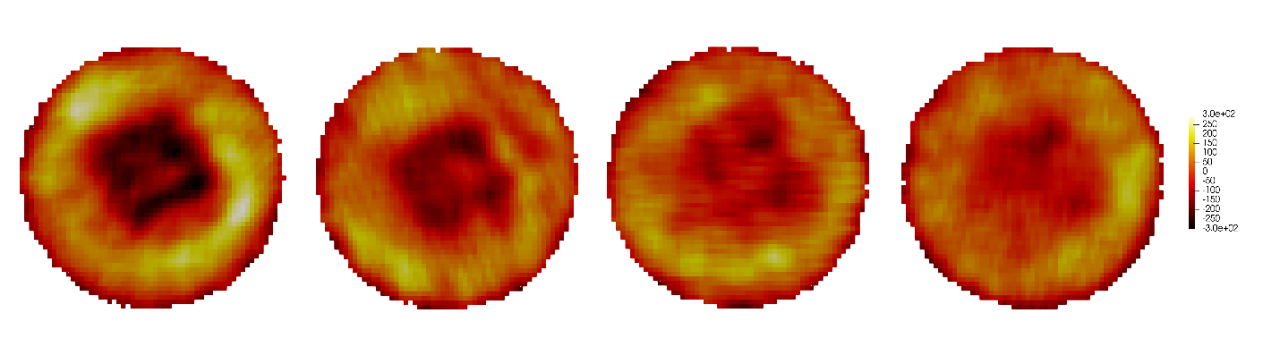
Figure 2: Melt pool area heat maps, normalized by layer, for 4 subsequent in-process monitoring layers. Stacked on top of one another, the closest points on each layer were recorded, creating a vector of melt pool area values assigned to each coordinate on the first layer. The diameter of the cylinder is 6 mm.
The intent of observing the melt pool area at a particular location for multiple layers directly above it is to monitor the change in melt pool area with each increase in the z-direction. It is generally assumed that during the additive process subsequent layers ‘heal’ or homogenize the structure on previous layers. While this may be true, it implies that focusing on detecting issues using raw in-process monitoring data is likely to result in significant amounts of ‘false positives’ because the next layer may heal the observation on the first layer. We propose to look for signals/patterns in the sequence of melt pool area measurements that may be more robust against over prediction of defects. In order to design metrics for the change in melt pool area, the four melt pool area values for sequential layers were subtracted from one another (equations 1-3).
It was observed that the orientation of the scan vectors with respect to the process gas flow direction caused layer-to-layer variance in the melt pool measurements, likely due to the gas flow direction’s effect on soot and spatter. The average melt pool area on a layer followed a cyclic pattern that significantly impacted the signal-to-noise ratio (shown in the supplementary material).To account for this, the melt pool areas are normalized for each layer by subtracting the mean melt pool area from each data point on the layer prior to performing further analysis. This ensures the average melt pool area, after normalization, on every layer is zero. Normalized melt pool area maps are shown in Figure 2.
$M_{1}=\left({MPA}_{L2}-{\overline{MPA}}_{L2}\right)-\left({MPA}_{L1}-{\overline{MPA}}_{L1}\right)$ (1)

$M_{2}=\left({MPA}_{L3}-{\overline{MPA}}_{L3}\right)-\left({MPA}_{L2}-{\overline{MPA}}_{L2}\right)$ (2)

$M_{3}=\left({MPA}_{L4}-{\overline{MPA}}_{L4}\right)-\left({MPA}_{L3}-{\overline{MPA}}_{L3}\right)$ (3)

After the development of these metrics, a baseline or nominal behavior needs to be established to determine what is anomalous and of potential interest. One dimensional, scalar metrics can be more easily analyzed by simple thresholds, which may be tied to values like the number of standard deviations from the mean, to determine outliers. In higher dimensions, the similarity of data points is more complicated and requires methods that are more sophisticated. In this work, we create a space where M₁, M₂, and M₃ are axes in three dimensions and we add a fourth dimension, the melt pool area on the reference layer. At first, it may appear that M₁ is linearly dependent on the melt pool area of the reference layer. However, this is not exactly true, since M₁ is the difference in the normalized melt pool area in the same local region on the reference layer and layer 2. It is possible for the same difference in normalized melt pool area to be observed when the melt pool area is relatively small or large on the reference layer. Figure 3 illustrates the first three dimensions as a Euclidean space and colors the data points by their fourth-dimension position for visualization purposes.

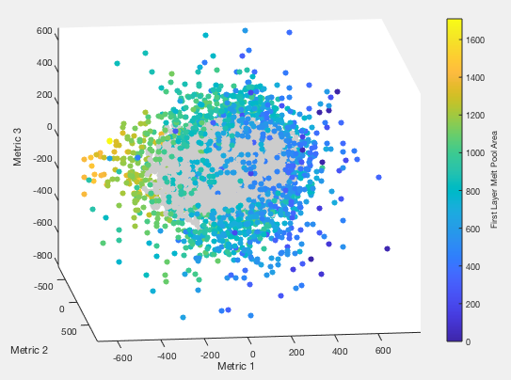
Figure 3: Using the same 4-layer window as Figure 2, a DB Scan algorithm labeled each point as an outlier or nominal. Grey points are nominal and the colored points are outliers
In order to identify points of interest in an unsupervised manner, the density-based spatial clustering of applications with noise (DBSCAN) algorithm was used to group the data. Given a point cloud of data in some space, DBSCAN separates closely packed point clusters (points that have numerous physically-close neighbors) and marks points whose nearest neighbors are far away as outliers. DBSCAN requires two controlling parameters, a minimum number of points to create a valid cluster and a neighborhood radius for searching; which were set in the current clustering to 100 and 40, respectively. Figure 3 shows how points were assigned, with grey points belonging to the main cluster (i.e. nominal processing response) and colored points being labelled as outliers (i.e. exhibiting non-nominal processing response). It is important to understand where the points that were assigned the outlier label are located in the actual geometry of the part. Figure 3 shows there exists two sections to this outlier group; the points to the right of the nominal group consist of generally smaller first layer melt pool areas while the points to the left consist of mostly larger first layer melt pool areas. Figure 3 explores where all outliers exist within the part and how the two different sections interact.
Figure 4a shows clearly a group of points with low reference layer melt pool area within the center of the part as well as a ring around the circumference. Scattered throughout the rest of the part are points with large reference layer melt pool area which are likely not indicative of a flaw (at least a lack of fusion defect of interest in this work). Figure 4b selects only outlier points with a first layer melt pool area that is below the average for the outlier group. This cleans up most of the extraneous points except for the outside ring while keeping the center largely intact. Figure 4c shows the raw CT image that correlates to the analysis window. It is clear that there is a similarity between the highlighted points in Figure 4b and the voids present in Figure 4c. A more detailed comparison of the predictability of voids from the in-process monitoring analysis will be presented in Section 4.
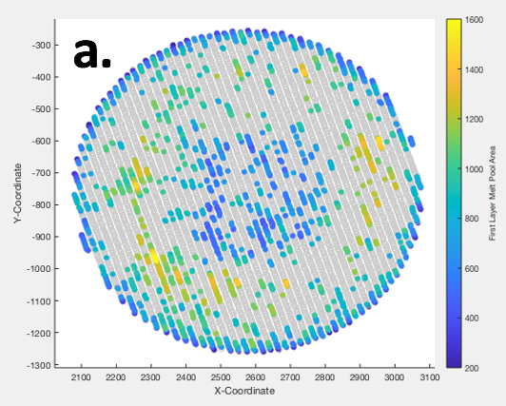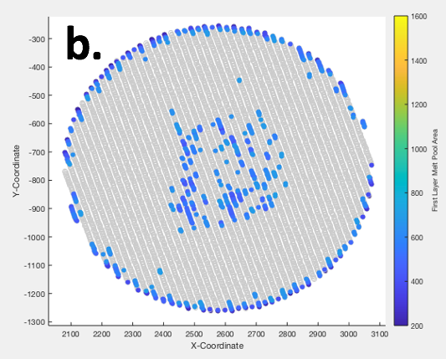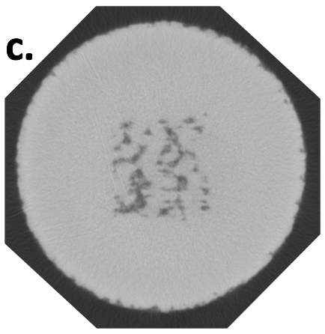
Figure 4: Plots of the points labeled as outliers by the DB Scan algorithm as they appear in the geometry of the part. The highlighted points are a) all outliers, b) outliers and the first layer melt pool area is below 700 (an arbitrary number that will be explored later).. Each point is colored by the reference layer melt pool area. c) shows the raw CT image that correlates to this layer of the part.
3.2.2 Computed Tomography (CT) Data Processing
After the CT data was collected, post-processing of the image stack was carried out using DREAM.3D [22] to identify the detectable defects. The raw CT data, which exists as a 3D image with floating-point values on each voxel, contains artifacts and noise from the collection and reconstruction process. The cylindrical samples investigated in this work result in relatively minor collection artifacts and noise when compared to more complex additive geometries, but were significant enough to complicate analysis. The first major artifact present in the data was drift in background intensity along the height of the cylinder, meaning the histogram of values on each layer of voxels perpendicular to the z-axis progressively shifted towards higher values. In order to establish a consistent threshold value to identify defects, the brightness on each layer needed to be equalized. Intensity equalization was done by calculating the mean brightness of the entire part and adjusting the mean brightness on each layer to match that of the entire part. A fixed value, equal to the difference of the layer’s mean from the part’s mean, was subtracted from each voxel on each layer, which shifted all means to equal the part mean without altering intensity variations within a layer. It is important to note that this process assumes there is no variation in overall density within the part up its height and the layer means should be consistent along the height. Often CT datasets also exhibit intensity variations through the thickness of the part (or radially for cylinders) due to beam-part interactions (like beam hardening). In this work, the intensity variations radially were minimal and did not require specific processing to improve quality.
Once the intensity was equalized throughout the part, it was necessary to reduce the higher frequency noise in the data, often referred to as ‘salt and pepper’ noise. A median filter was used to smooth the higher frequency noise without blurring the overall image content. The median filter was set to a radius of three voxels in all dimensions, meaning a 7x7x7 voxel window was centered on each voxel in 3D image and the center voxel’s value was changed to the median value of the voxels in the window. After smoothing the high frequency noise, the data was smooth enough and demonstrated a sufficient contrast that a simple manual intensity threshold could be used to distinguish defects from solid material. In practice, an automated thresholding technique, like the Otsu method, would be a more efficient approach to determining thresholds for many datasets, but was not implemented in this initial work. Application of the intensity threshold resulted in a binary image with low density regions (i.e. voids) labelled as 1s and high density regions (i.e. solid material) as 0s.
Rather than use the binary image directly, we chose to further process the CT data to obtain a more statistical representation of spatial variation of voids within the volume. Our reason for this additional processing was multifold. First, many of the factors in void generation, such as local powder packing, gas flow, and plasma plume are not measured by the in-process monitoring system, which makes predicting any one void unlikely. Second, methods for registering and fusing the data (discussed in the next section) are likely not precise enough to register the in-process monitoring with the CT to an accuracy below the size of most detectable voids (~50μm). Third, the in-process monitoring measurements have an interrogation area/volume larger than most voids detected by CT, which makes associating a single void with a single in-process measurement tenuous. Finally, utilization of the knowledge of defects/voids in the build is likely to be probabilistic in nature, meaning the probability of material to perform at its desired level is what defines acceptable quality. Given these points, we process the binary CT image with a box mean filter of 5x5x2 voxels (~150μm x 150μm x 50μm in XYZ, respectively) passed over each voxel. By calculating the mean of the binary map within each window, the fraction of voxels that are voids (v_{f}) within that window is obtained and assigned to the central voxel of the window. The result is no longer a binary image of voids, but more of a map of the local probability of voids within a fixed distance. The processing steps discussed are shown below in Figure 5a-d. As previously mentioned, a complicating issue is that the void locations are displaced in the z-direction from the in-process monitoring data that is likely to be influenced by their presence. To combat this problem, we devised a modified v_{f} metric, that averages the v_{f} values for 5 points below each grid point to capture the propensity of voids not only at the same build height as the in-process monitoring measurements, but also directly below them for a distance deemed reasonable for additive manufacturing (~5 build layers). The modified v_{f} metric was used in training the regressor to predict void propensity using the in-processing monitoring data from the cylindrical samples.

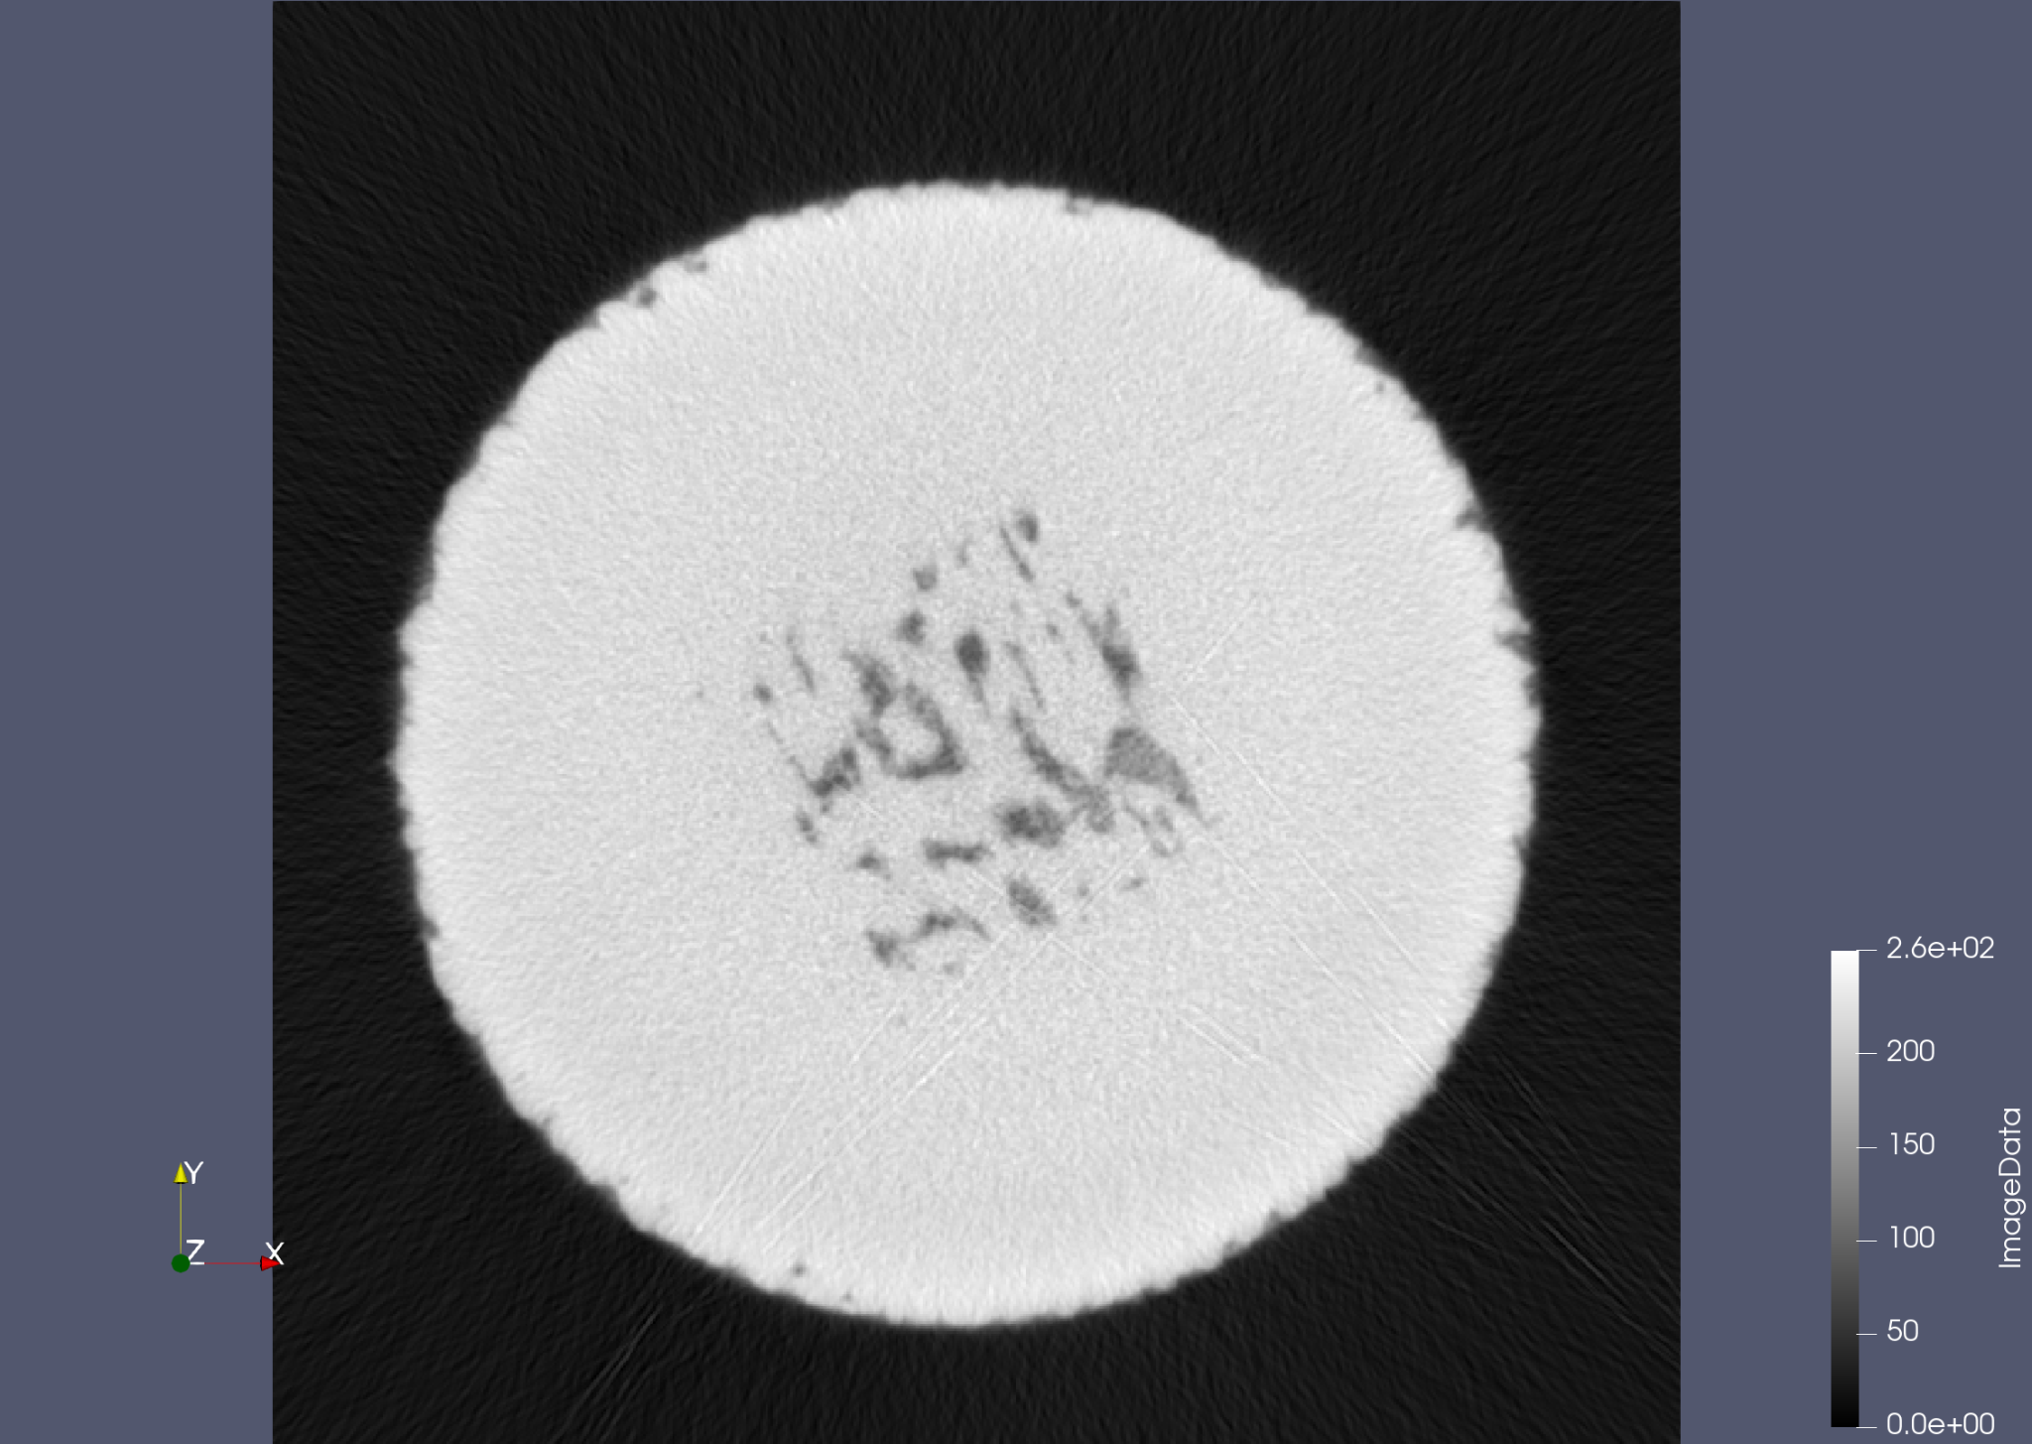 | 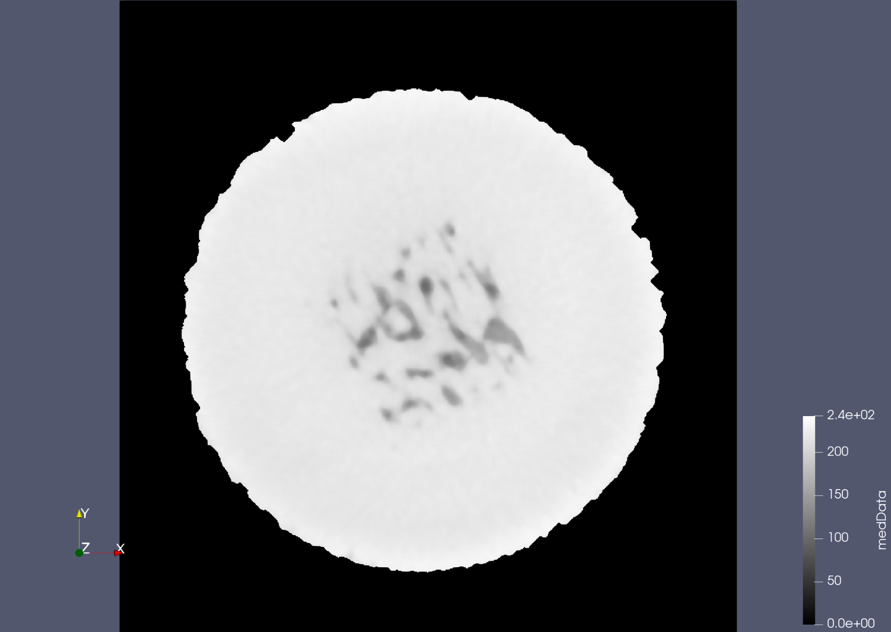 | 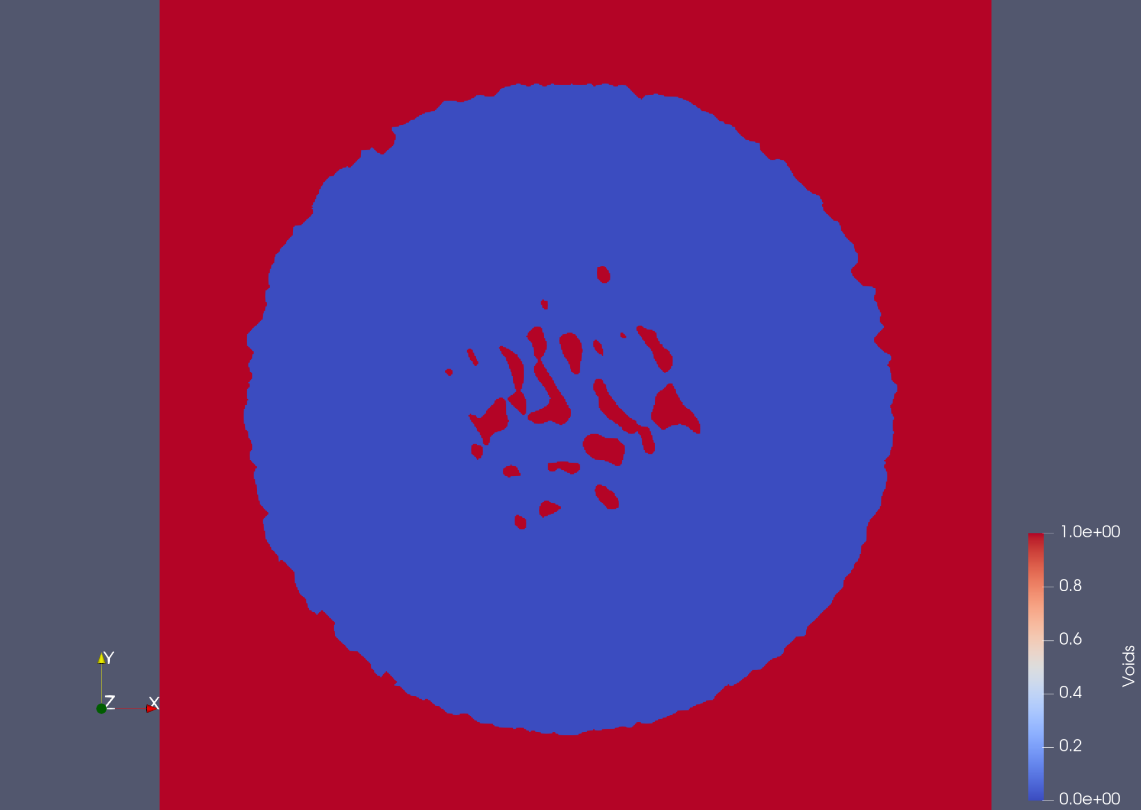 | 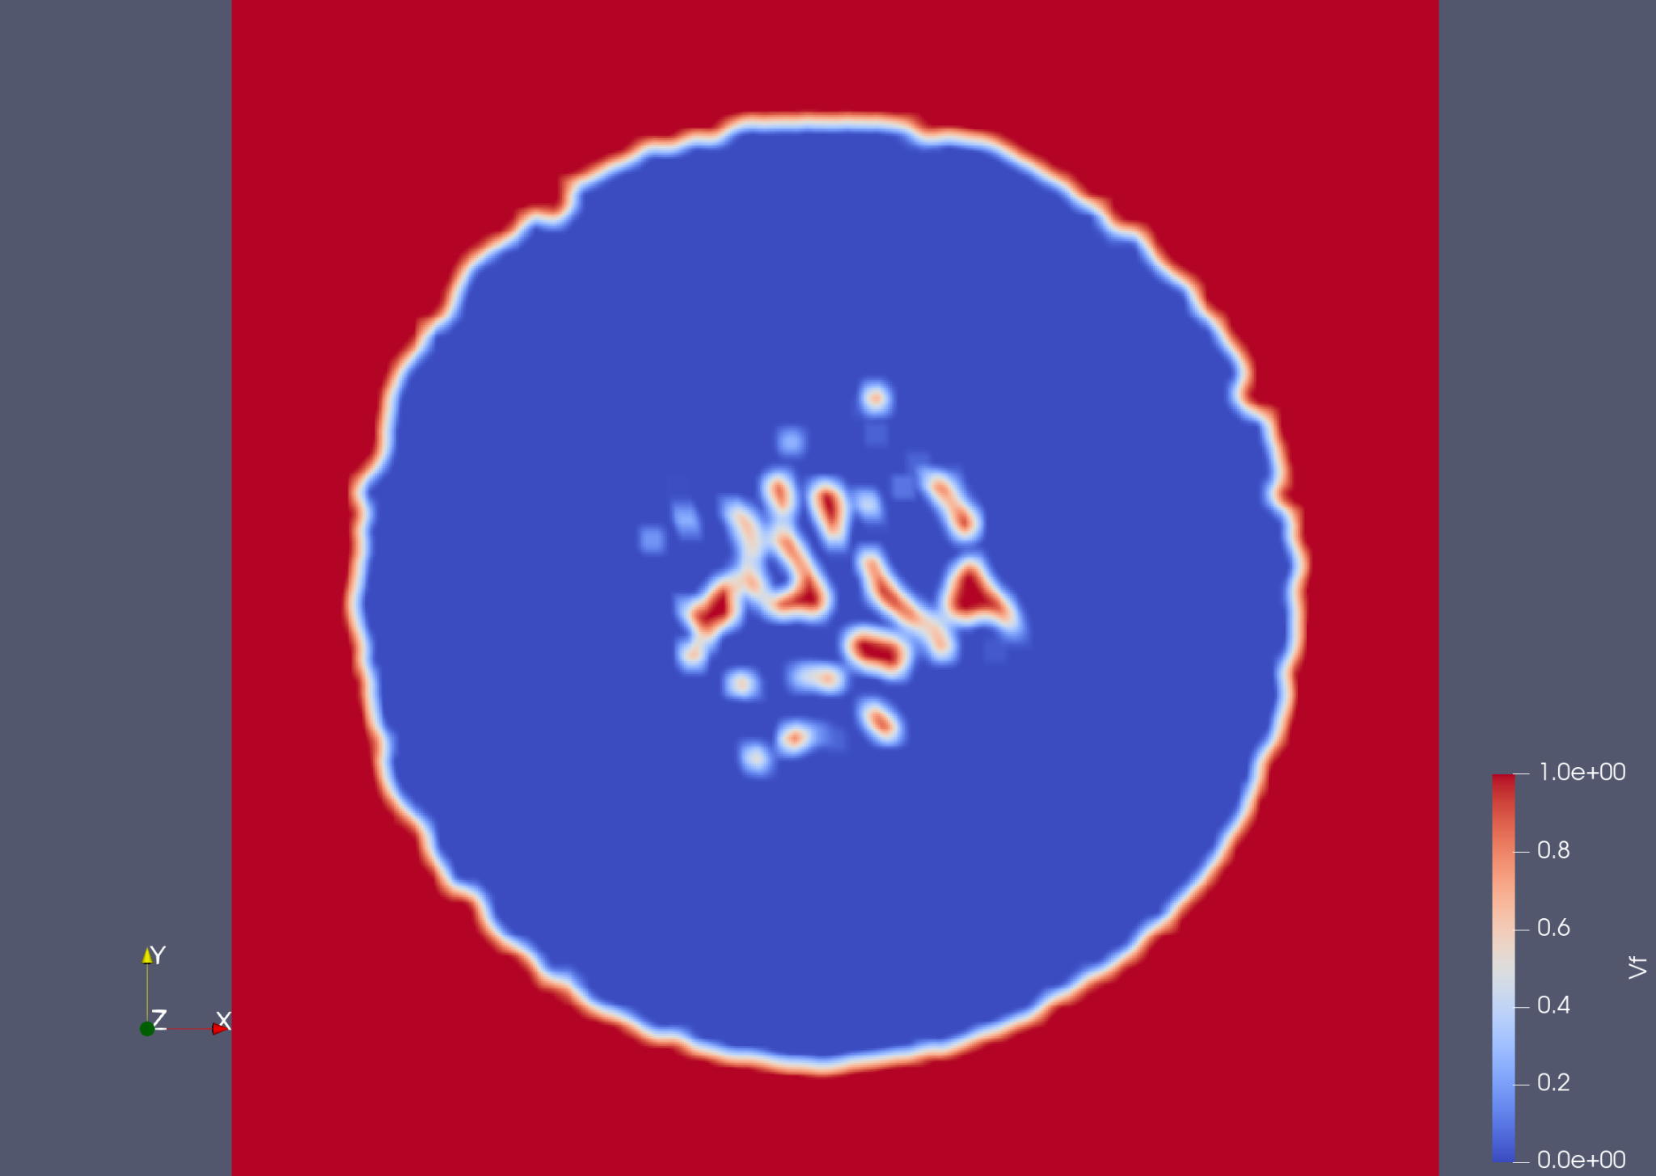
Figure 5: Example slice of the raw CT data (a.), leveled and median blurred data (b.), identified voids (c.), and the smoothed void volume fraction (d.)
3.3 Data Registration and Fusion
The CT and in-processing monitoring data streams must be registered, or brought into spatial coincidence, to assess correlations between them. Registration of the data streams is complicated by two factors; first, the data element dimensionality varies from 0D (point clouds) to 3D (image grids); and second, the data streams contain different information content which may not necessarily correlate. Utilizing correlated information approaches, such as mutual information, to register the data sets could bias subsequent analyses. Ideally when performing registration, the samples would contain some independent reference marks detectable in each of the data sets, which would aid registration without introducing bias. For this work, these ‘reference marks’ were selected to be the sample surfaces themselves. The sample surfaces are not guaranteed to all match exactly, because the in-process monitoring data is where the beam rastered and the CT data captures a measurement of the physical build (which could be affected by residual stresses and distortions, artifacts in the CT reconstruction, and from cutting of the sample off the build plate). However, the simple and relatively ‘bulk’ geometry used in this work (a cylindrical rod), these geometric distortions and reconstruction artifacts were minimal.
The specimen in this work was a cylindrical rod with a slightly reduced cross-section over the middle one-third of the cylinder’s height, which aided in positioning along the build direction. Additionally, there were embedded features within the cylinder, which will be discussed in Section 3, that were square and broke the rotational symmetry of the cylinder. The first step in the registration process is to identify ‘key points’ in each dataset that correspond spatially; this step involves extracting out points that represent the part surface. The CT data was thresholded using a local gradient approach to determine the voxels that were at the surface of the sample [23]. The in-process monitoring data was thresholded to contain only points when the beam was ‘blanked’, which corresponds to when the beam is turning around at an internal scan vector boundary or at the part surface. The second step is to use some algorithm to determine the translations, rotations and distortions necessary to bring the key points into coincidence. In practice, this second step can be automated through use of an algorithm such as the iterative closest point (ICP) algorithm [24-25]. However, since the focus of this work was the analysis of the fused datasets over the registration process, which is discussed in more detail in [26], the transformations we determined manually in Paraview [27]. For this work, we chose to apply the transformations to the in-process monitoring point cloud, even though the in-process monitoring should be in the proper reference frame of the build. This choice was made because no interpolation in needed when transforming a point cloud, since the data remains an unstructured set of points. However, if the CT image is transformed into a new reference frame, the voxels will likely not align with the coordinate system and a new grid would be needed, which would require interpolation and further data manipulation that can be avoided for the correlative analysis that follows.
Upon registering the two datasets, they need to be fused onto a single set of discrete locations. We choose to create a new grid of points that have a spacing in the x-, y-, and z-directions approximately equal to the box mean filter applied to the CT data (150μm x 150μm x 50μm) as the reference grid onto which we will map both the CT and in-processing monitoring data. The CT data is on a regular grid and the v_{f} values discussed earlier were calculated within windows equal to the new grid’s voxels. As such, it is intuitive to simply assign the v_{f} from the closest CT point to each of the new grid locations. The in-process monitoring data is more complicated, being in the form of 3D point clouds with ‘sheets’ of data spaced by the layer thickness in the z-direction and bands of data (along melt vectors) spaced by the hatch spacing within the ‘sheets’. The spatial density of the in-process monitoring measurements is not uniform, with the point density along a melt vector about twice that in the build direction and 5 times that of the direction perpendicular to the melt vector. It should be noted that while the direction of melt vectors rotates between layers, making the point density relatively uniform within a layer in the average sense, any given layer is sampled with significant non-uniformity. Additionally, as noted previously, the in-process measurements are not truly reflective of a single point in space, but are associated with the position of the beam when the measurement was made. Since the melt pool area is on the order of 150μm in this build, we chose to broaden each in-process monitoring point to have an ‘influence region’ equal to a circle (in the print layer it was collected on) with 150μm diameter. When mapping the in-process monitoring points to the new grid, each in-process monitoring point within 150μm of a grid point was added to a list for that grid point. At each of the new grid points, each of the metrics describing the set of in-process monitoring points in its list were averaged and assigned to the grid point. Upon completion of the registration and fusion process, there exists a single grid of points that each have associated with them: a v_{f}, an averaged reference layer melt pool area, three averaged metrics defining the change in local melt pool area on the layers above, and a percentage of local in-process monitoring points flagged as outliers. We will discuss the analysis of this combined dataset in the next section.
3.4 Machine Learning of Relationship Between In-Process Monitoring Signatures and CT Void Indications
The end goal of fusing the CT and in-process monitoring is to establish if a quantitative relationship exists between the two data streams. Machine learning methods are data-driven models that can feel like ‘black boxes’ that link inputs to outputs using an unexplainable, complex set of functions. In this work, we have attempted to design understandable features and also chose a machine learning approach built on decision trees [28]. A decision tree operates like a flow diagram, where nodes separating branches apply a test to the features and branches ultimately terminate at a leaf node, representing an output class label. Decision trees can often lead to overfitting [29], so it is common to utilize numerous decision trees in an ensemble learning strategy, which is termed the random forest method. Each tree is built on a random subset of the training data, using a random subset of the feature set thus bringing stochasticity while training the model which helps in avoiding overfitting the training dataset. The output from each of the decision trees is then voted to get a final prediction of the propensity of detected voids given the interpolated in-process monitoring predictors (i.e. metrics 1-3 defined in section 2.2.1) at all locations in the sample. A schematic of the random forest approach is shown in Figure 6. We utilized Scikit-learn’s RandomForestRegressor implementation in Python. The 3D image dataset was transformed to a tabular dataframe, where each row corresponded to a grid point and were comprised of columns of v_{f} and the in-process monitoring predictors. The data were then split into testing and training datasets using sklearn.model_selection’s train_test_split method and passed into the RandomForestRegressor object. Two regressions were done, the first of which used the local region’s normalized melt pool area on the reference layer only (the fourth dimension in the data space described in 3.2.1) to predict the voids, which is termed the naive prediction. The second regression used the full four-dimensional feature vector for each local region as predictors. Both models were used to create predicted v_{f} values, which were mapped back to the 3D image grid for visual comparison.
Results were quantitatively evaluated in two ways. First, sklearn.metrics’ r2_score method, which computes the coefficient of determination, was used to assess the ability of the regressor to predict the continuous probability of voids in a region (i.e. v_{f}). Second, the predicted and actual v_{f} values were threshold to obtain a binary classification (ie low probability and high probability of voids). For this work, we chose 0.05 as the threshold for high probability of voids, meaning 5% of voxels near the location are associated with voids. The comparison of binary classification quality can be done by computing a variety of statistics such as recall, precision, and type I and II error. An additional benefit of the random forest method is that the feature importance can be computed to determine which metrics are most predictive and which may be more tenuous. This importance score can be useful in feature engineering to extract more useful metric from the in-process monitoring and increase predictability. In this work, it was seen that while the melt pool area on the reference layer was determined by the regression to be the most important to predicting void probability, the melt pool areas from the subsequent three layers were used nearly equally and provided almost the same importance as the reference layer. A graph of the importance of each feature is shown in the supplementary material.
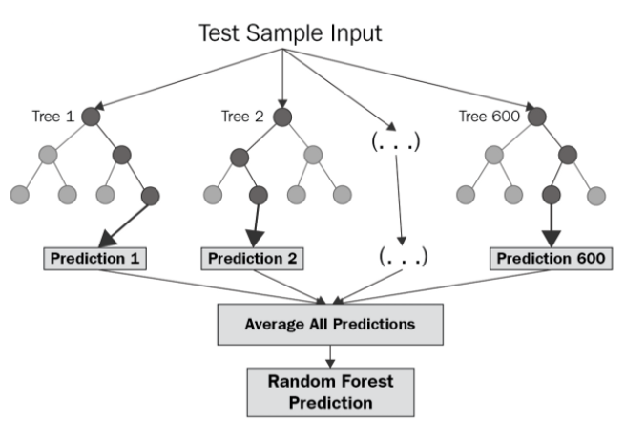
Figure 6: Schematic of the random forest method illustrating the multiple decision trees and the aggregation of their predictions to create an ensemble prediction of the classification of the input data.
4. Results
In effort to test the predictive ability of the framework discussed above, we designed an experiment to intentionally insert defective material within otherwise nominal processing conditions that we have observed to yield high quality material (with respect to density). The methods used to insert the defective material precludes predicting the ‘initiation’ of the defects, but we can test the ability to detect if there is defective material underneath an otherwise nominal layer and whether the nominal layer likely healed the defect. In this section, we will outline the experiment and present the results of the methodology.

The in-process monitoring and CT data streams from one of the cylinders were processed as described in the previous sections and two statistical models relating in-process monitoring signals to local void density were learned. Figure 7 shows scatter plots of the predictions of local void density from these models compared to the actual local void density observed from CT. The plots show that, in general, both models underpredict the amount of local voiding, since it can be seen that most points fall above the identity line in both plots. However, in the naïve prediction, which is shown on the left in Figure 7 and use only the normalized reference layer melt pool area, the points are further from the identity line, especially along the x-axis (corresponding to false positives). The full prediction, which is shown on the right in Figure 7 and uses the four dimensional feature vector, shows the points moving towards the identity line and reducing the number of points located directly along the x and y axes. The deviation from the identity line suggests additional processing is needed. Investigation into the location of the points furthest off the line most commonly showed locations that were in the defected regions that were predicted have low local voiding (i.e. false negatives). However, in most cases, the points immediately surrounding these false negatives were well predicted, which suggests a further coarsening of the data may help smooth predictions. This is will be discussed further below and in the conclusions.
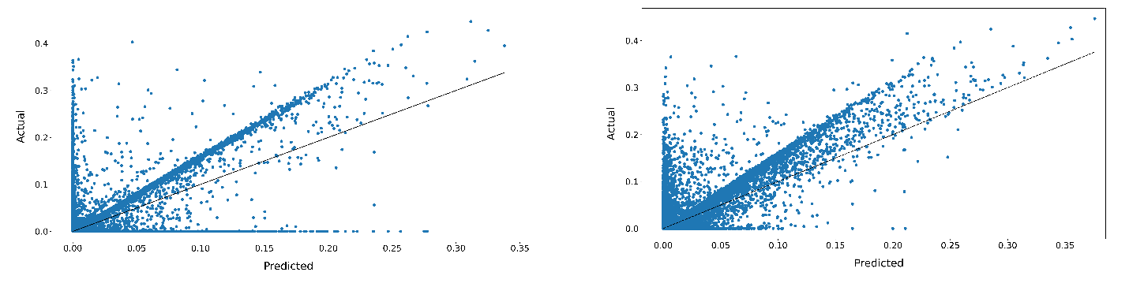
Figure 7: left) scatter plot showing the predicted vs actual modified v_{f} metric from the CT data for each spatial location in the cylinder using the naïve prediction and right) scatter plot showing the predicted vs actual modified v_{f} metric from the CT data for each spatial location in the cylinder using the full prediction.
Beyond inspecting for general predictability of the models, it is useful to visualize the predictions in real space to see if there are systematic errors tied to spatial locations. Figure 8 shows the visual comparison of the statistical model prediction to the processed CT data for three different layers, each just above inserted defected regions. . It is clear from the images that the predictions qualitatively match the patterns seen in actual CT data. It should be noted that while the defected regions were printed with uniformly poor processing conditions, the entire region does not have voids and there are local heterogeneities in the local void density within the regions. The predicted local void densities do a good job capturing these heterogeneities. However, there are deviations in the magnitude of the local void density, with the predicted values generally being too low (as seen in Figure 7). Additionally, there are some locations where the predicted values appear to have a ‘hole’, where a small region of low predicted values are surrounded by high predicted values. Deviations between the predicted and the actual local void density could be due to multiple factors. First, the set of input features/metrics may not be complete enough to capture all voids. Second, the manual alignment and thresholding may have resulted in positional uncertainty, which introduces uncertainty in the regression. Third, the in-process monitoring data has some high-frequency variation that can be caused by spatter and ejecta events, which may not have been completely smoothed out. Finally, the voids in AM materials come from multiple sources (feedstock porosity, keyholing, lack of fusion, powder distribution, etc.), which may not be captured in the in-process data stream at all.

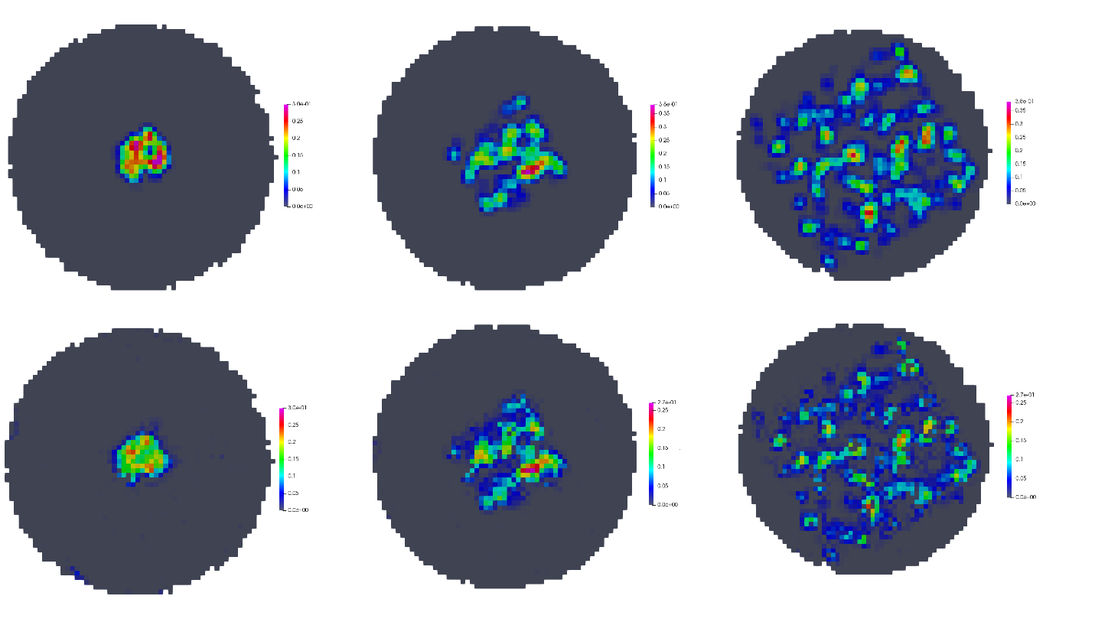
Figure 8: top) actual modified v_{f} metric from the CT data for three different layers in the cylinder directly above one of the inserted defect patches and bottom) the predicted modified v_{f} metric from the random forest regression for the same layers.

4. Conclusions
In this work, we have shown a methodology for processing a combining in-process monitoring data from AM builds with post-build inspection, like CT. The registration and merging of the data allows for statistical analyses, like random forest regression, to be performed to learn statistical models that relate the two data streams. We have shown that designing features/metrics that can be extracted from the in-process monitoring data can go beyond the raw signals and offer the potential for more predictive power when predicting the local probability of defects. Initial results show that there is improvement in predictability with reduced false positives. However, there is clearly more work to be done to improve the overall utility of the in-process monitoring data. Spatial agreement of the predictions show good visual agreement, with somewhat reduced intensity.
Author Conflicts of Interest
The authors declare that they have no conflicts of interest.
References
- Kolb, T. et al. “Qualification of channels produced by laser powder bed fusion: Analysis of cleaning methods, flow rate and melt pool monitoring data.” Additive manufacturing 25 (2019): 430-436.
- Bisht, M. et al.. “Correlation of selective laser melting-melt pool events with the tensile properties of Ti-6Al-4V ELI processed by laser powder bed fusion.” Additive Manufacturing 22 (2018): 302-306.
- Luke Scime and Jack Beuth "Using machine learning to identify in-situ melt pool signatures indicative of flaw formation in a laser powder bed fusion additive manufacturing process" Additive Manufacturing 25 (2019): 151-165
- Seifi, M., Salem, A., Beuth, J. et al. “Overview of Materials Qualification Needs for Metal Additive Manufacturing” JOM 68 (2016): 747–764
- Bartlett JL et al. "In situ defect detection in selective laser melting via full-field infrared thermography" Additive Manufacturing 24 (2018): 595-605
- Darvish K. et al. "Reducing lack of fusion during selective laser melting of CoCrMo alloy: Effect of laser power on geometrical features of tracks" Materials & Design 112 (2016): 357-366
- Mukherjee, T., Zuback, J., De, A. et al. Printability of alloys for additive manufacturing. Sci Rep 6, 19717 (2016).
- King WE et al. "Observation of keyhole-mode laser melting in laser powder-bed fusion additive manufacturing" Journal of Materials Processing Technology" 214:12 (2014): 2915-2925
- Gong H et al. "Analysis of defect generation in Ti–6Al–4V parts made using powder bed fusion additive manufacturing processes" Additive Manufacturing 1–4 (2014) 87-98
- Zhang, B., Li, Y. & Bai, Q. Defect Formation Mechanisms in Selective Laser Melting: A Review. Chin. J. Mech. Eng. 30, 515–527 (2017)
- Everton S. et al. "Review of in-situ process monitoring and in-situ metrology for metal additive manufacturing" Materials & Design 95 (2016): 431-445
- Basak, A., & Das, S. (2016). Epitaxy and Microstructure Evolution in Metal Additive Manufacturing. Annual Review of Materials Research, 46, 125-149.
- Energetics Incorporated, Measurement Science Roadmap for Metal-Based Additive Manufacturing, National Institute of Standards and Technology, Maryland, US.,2013
- S. Berumen, F. Bechmann, S. Lindner, J.-P. Kruth, T. Craeghs, Quality control of laser-and powder bed-based Additive Manufacturing (AM) technologies, Phys. Procedia5 (Part B) (2010) 617–622.
- S. Clijsters, T. Craeghs, S. Buls, K. Kempen, J.P. Kruth, In situ quality control of the selective laser melting process using a high-speed, real-time melt pool monitoring system, Int. J. Adv. Manuf. Technol. 75 (5) (2014) 1089–1101 (English).
- T. Furumoto, M.R. Alkahari, T. Ueda, M.S.A. Aziz, A. Hosokawa, Monitoring of laser consolidation process of metal powder with high speed video camera, Phys.Procedia 39 (1) (2012) 760–766.
- M A Groeber et al 2017 IOP Conf. Ser.: Mater. Sci. Eng. 219 012002
- Fisher BA et al. “Toward determining melt pool quality metrics via coaxial monitoring in laser powder bed fusion.” Manuf Lett. 15 (2018):119-121
- J.-P. Kruth, P. Mercelis, J. Van Vaerenbergh, T. Craeghs, Feedback control of selective laser melting, Proceedings of the 3rd International Conference on Advanced Research in Virtual and Rapid Prototyping, (2007), pp. 521–527.
- N.N. Neue Möglichkeiten mit 3D (New Possibilities in 3D), Werkzeug & Formenbau, 9 (4) (2015), 64-66.
- N.N. Positionsbezogene Echtzeitüberwachung und dreidimensionale visualisierung (Position-correlated real-time monitoring and three-dimensional visualization), WOMag, (9) (2015), 1-3.
- M.A. Groeber, M.A. Jackson, DREAM.3D: A digital representation environment for the analysis of microstructure in 3D, Integrating Materials and Manufacturing Innovation. 3 (2014) 56-72, https://doi.org/10.1186/2193-9772-3-5.
- G. Lehmann. Robust Automatic Threshold Selection. The Insight Journal, July 2006, (http://hdl.handle.net/1926/370).
- P.J. Besl and Niel D. McKay. A method for registration of 3-D shapes. IEEE Transactions on Pattern Analysis and Machine Intelligence, 14(2):239-256, 1992.
- Radu Bogdan Rusu and Steve Cousins. 3D is here: Point Cloud Library (PCL). IEEE International Conference on Robotics and Automation (ICRA), May, 2011.
- SP Donegan, EJ Schwalbach, and MA Groeber, Multimodal Registration and Fusion of In Situ and Ex Situ Metal Additive Manufacturing Data, submitted to JOM. 2021
- Kitware. http://www.paraview.org/
- I Jenhani, N Ben Amor, and Z. Elouedi, Decision tress as possibilistic classifiers, International Journal of Approximate Reasoning, 48(3):784-807, 2008.
- TM Hehn, JFP Kooji, and FA Hamprecht, End-to-end learning of decision tress and forests, International Journal of Computer Vision, 128:997-1011, 2020.

Supplementary Material

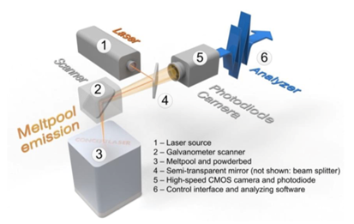
Supplementary Figure 1: Principle and main components of QM Meltpool 3D system [24]

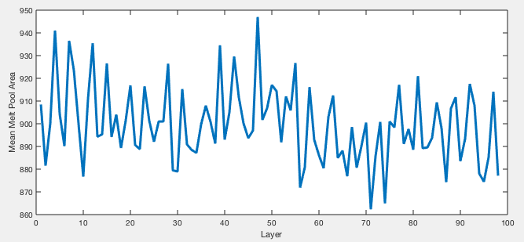
Supplementary Figure 2: Layer average melt pool area as a function of the layer number. This is an example from a completely nominal portion of the part showing variation in the melt pool areas on each layer.
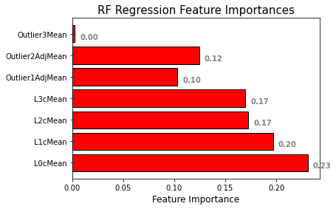
Supplementary Figure 3: Graph showing the importance of each metric in the random forest regressor’s predictability of the void probability.

